https://en.support.wordpress.com/shortlinks/:

Shortlinks (support.wordpress.com)
Contents
Shortlink from the new Post/Page Editor 1
Shortlink from the WP Admin Post/Page Editor 1
Shortlink from Action Bar 2
Why use wp.me? 2

You may already be using one of the popular URL shorteners, such as bit.ly or TinyURL, to publish shortened links on Twitter or other services.
WordPress.com has its own URL shortening feature, wp.me, so that you can quickly and easily get shortlinks to your blog posts/pages and share them with the world.
Shortlink from the new Post/Page Editor
- Go to Blog Posts/Pages (Add) or open a previously published post in the editor.
- Expand “Sharing” section from the left column.
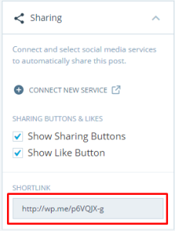
- Copy the link and share with the world! (Shortlink will only be visible for posts that are published.)

Shortlink from the WP Admin Post/Page Editor
- Go to Posts/Pages -> Add New or open an existing post/page in editing mode.
- Directly under the title field, next to the post/page Permalink, you will see the Get Shortlink button.
- Click Get Shortlink and a dialog box will appear with the post/page’s shortlink. Copy it and share it with the world.
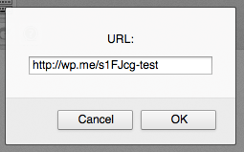

Shortlink from Action Bar
Viewing a particular post or page? Get its shortlink from the new Action Bar. Look for it at the bottom-right of the screen.
- Go to an individual post or page.
- Click the three “dots” that appear at the bottom-right. If you don’t see them, just scroll up a bit.
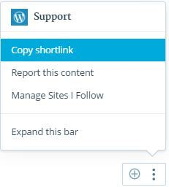
- “Copy shortlink” and share it away!

Why use wp.me?
Sure, the functionality is the same as other URL shortening services, but WP.me is different in a few ways:
- Every blog and post on WordPress.com has a WP.me URL now.
- These are all exposed in the <head> using rel=shortlink.
- It doesn’t work for any URL in the world, just WordPress.com-hosted ones.
- The links are permanent, they will work as long as WordPress.com is around.
- WP.me is spam-free, because we are constantly monitoring and removing spam from WordPress.com.

